1. Git Setup https://confluence.atlassian.com/bitbucket/set-up-git-744723531.html

**sudo apt-get install git  
git --version**

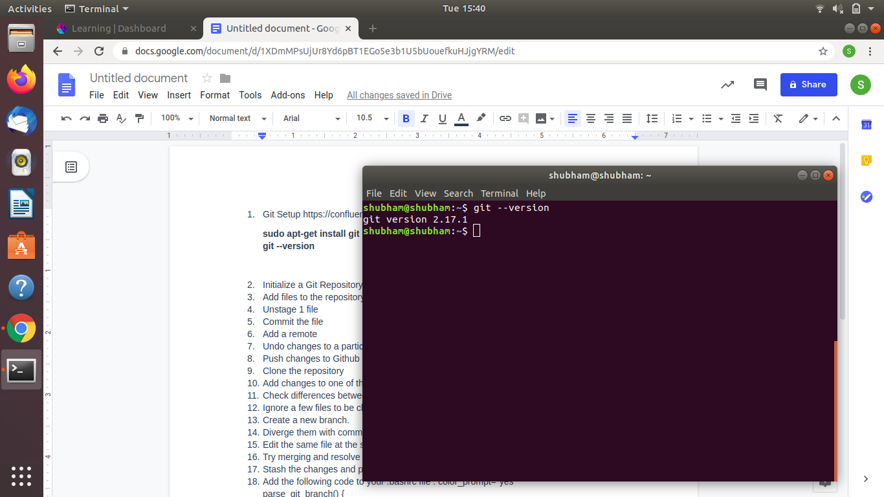

1. Initialize a Git Repository

**mkdir demo  
cd ~/demo  
git init**

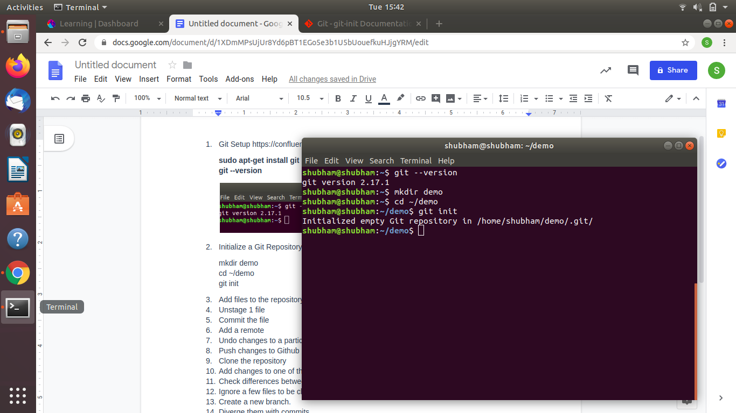

1. Add files to the repository

**cat > file1.txt  
git add file1.txt (stage)**

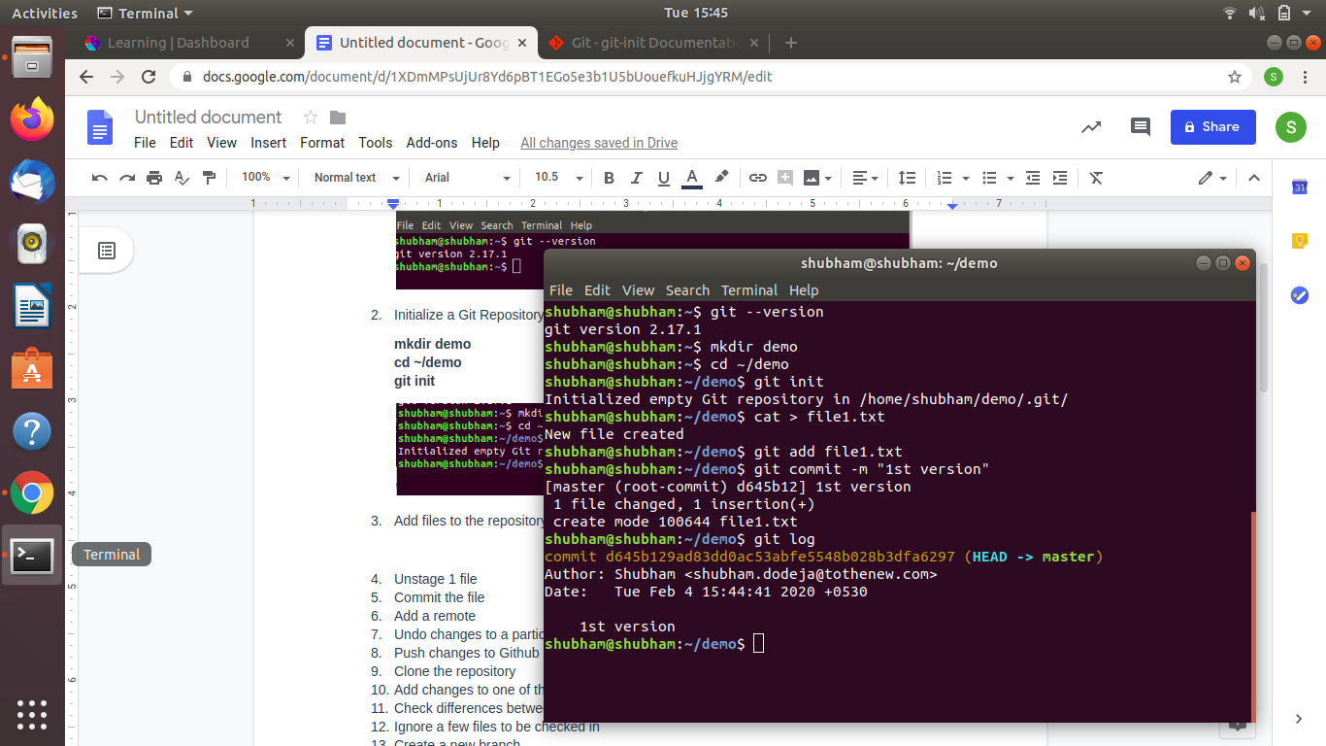

1. Unstage 1 file

**git add file1.txt (stage)  
git reset -- file1.txt (unstage)**



1. Commit the file

**cat > file1.txt (creating file)  
git add file1.txt (staging)**  
**git commit -m "1st version" (commit)**



1. Add a remote

**git remote add demo /home/shubham/demo/.git/  
git remote -v**

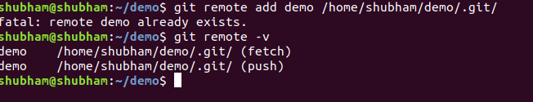

1. Undo changes to a particular file

**git checkout -- file1.txt**

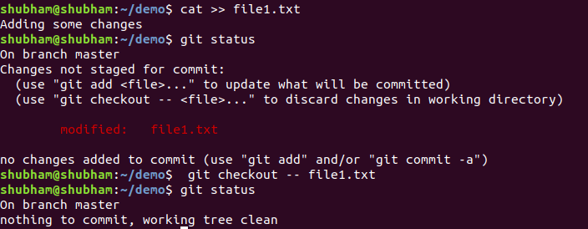

1. Push changes to Github

**Git push --set-upstream final branch1**

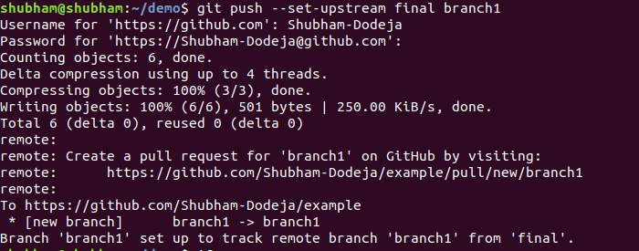

1. Clone the repository

**git clone https://github.com/Shubham-Dodeja/example.git**

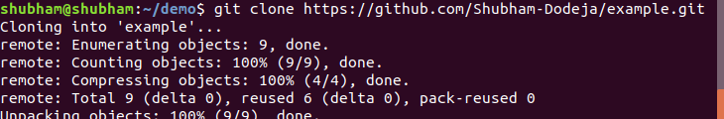

1. Add changes to one of the copies and pull the changes in the other.

**git pull**

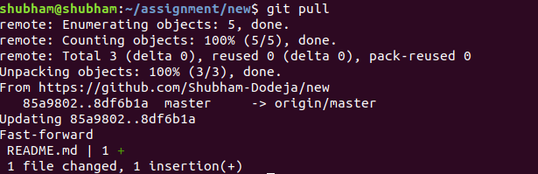

1. Check differences between a file and its staged version

**git diff**

**A file which isn’t stage generally appears red in the terminal while one that is staged appears in green. Moreover a staged file is saved in the index while one which isn’t is processed in workspace.**

**A normal file is Untracked file while a staged file can be commited**

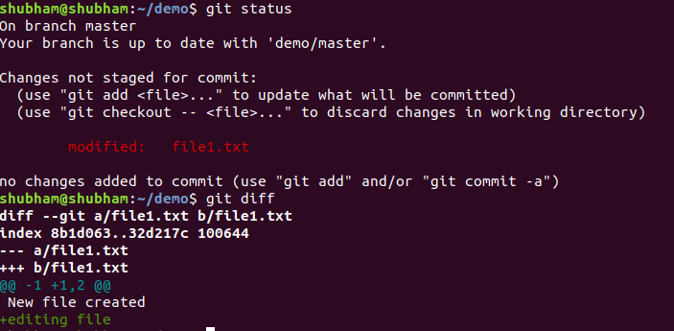

1. Ignore a few files to be checked in

**touch .gitignore  
git rm --cached myfile.txt  
Git status**

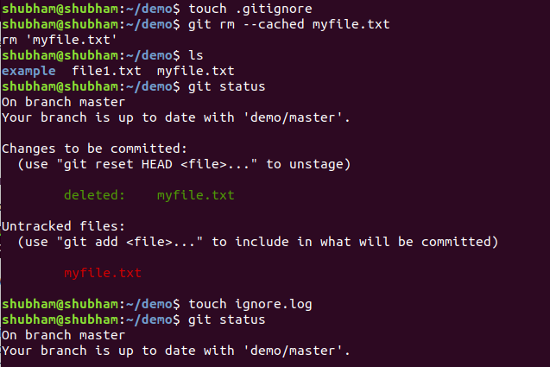

1. Create a new branch.

**git checkout -b "branch1"**



1. Diverge them with commits

**git checkout branch1  
edit a file  
Git commit -m “message”**

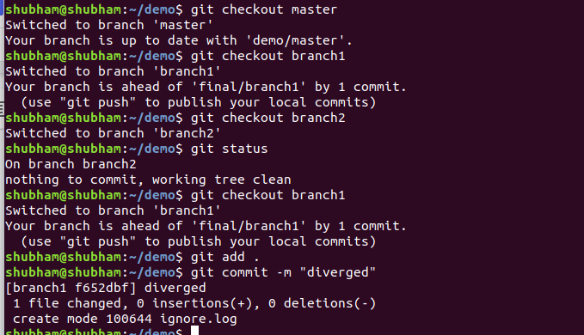

1. Edit the same file at the same line on both branches and commit

**gedit file1.txt  
git status**

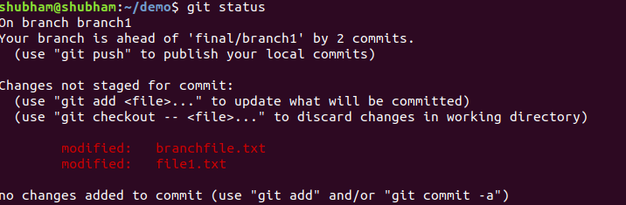

1. Try merging and resolve merge conflicts

**git merge branch2**

**The most direct way to resolve a merge conflict is to edit the conflicted file. Open the file1.txt file in editor.**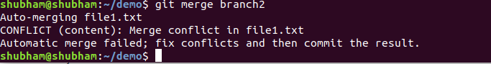

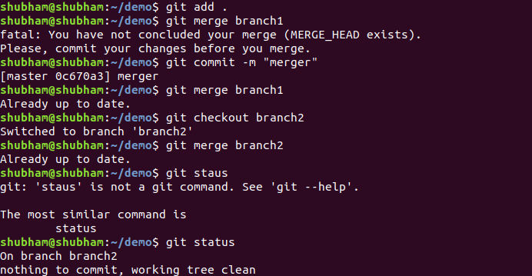

1. Stash the changes and pop them

**cat >> copyfile.txt  
git status  
git stash  
git status  
git stash pop**

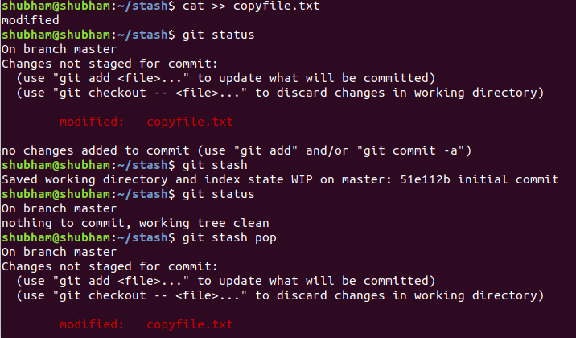

1. Add the following code to your .bashrc file : color_prompt="yes"  
   parse_git_branch() {  
   git branch 2> /dev/null | sed -e '/^[^*]/d' -e 's/* \(.*\)/(\1)/'  
   }  
   if [ "$color_prompt" = yes ]; then  
   PS1='\u@\h\[\033[00m\]:\[\033[01;34m\]\W\[\033[01;31m\] $(parse_git_branch)\[\033[00m\]\$ '  
   else  
   PS1='\u@\h:\W $(parse_git_branch)\$ '

**gedit ~/.bashrc**

